Joseph craft ideas
Here are some biscuits that you could decorate and a more healthy option using 2 large crackers or bread and fruit. Don’t forget to take a photo of what you have made before you eat it.
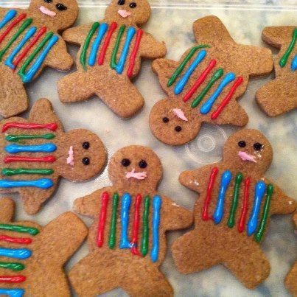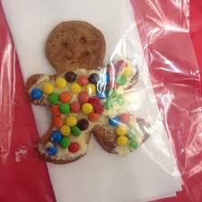
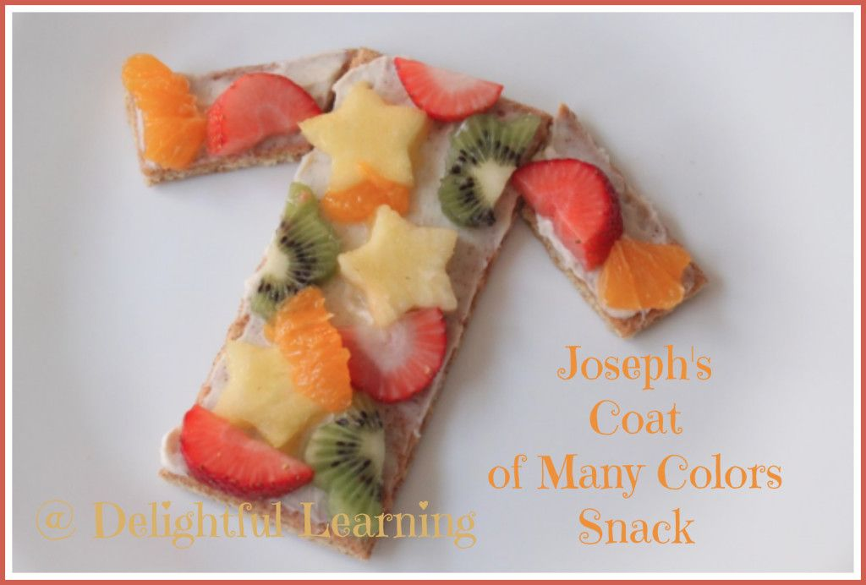

You can draw a simple outline for a coat on A4 paper and then decorate it with coloured pens or tissue paper or fabric or wool. You could make a larger one and paint it. Have fun and use any materials that you have at home to make a bright colourful coat. Here are some ideas that other people have done:
