Jonah craft ideas
- Decorate your origami fish using shiny things and then put a piece of cotton through the top fin and hang it up
- You can make several of the origami fish and make a picture out of them. You could ask others in your family to make some for you so you have plenty.
- You can use a peg, blue card or blue foam and paper to draw Jonah
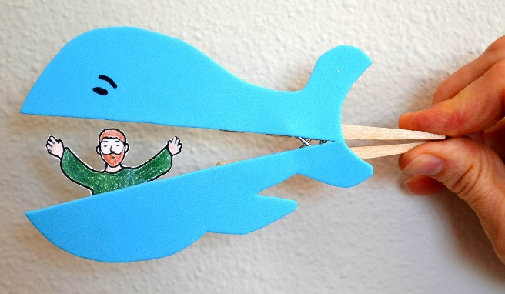
- You can use a plastic or paper cup, some card for the whales tail googly eyes or some paper that you cut out for the eyes, a piece of string and a table tennis ball or something like a small pencil rubber and draw on a man. You can make this into a game of catch.
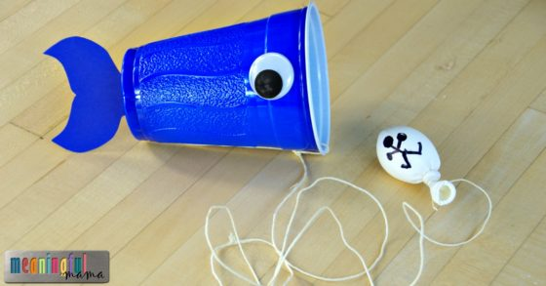
- Various food crafts. Use what ever you have. Perhaps take a photo before you eat it. These are just some ideas.
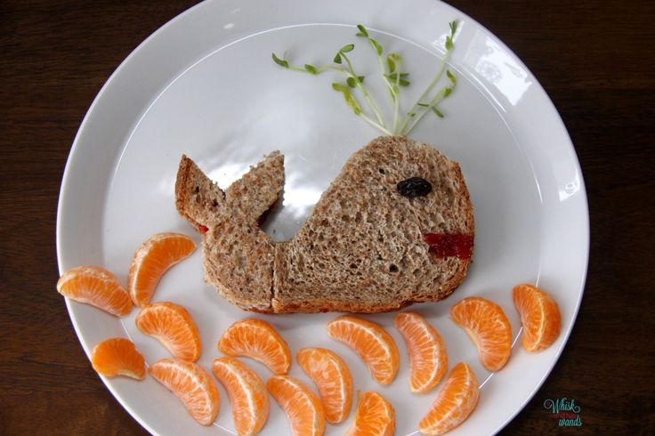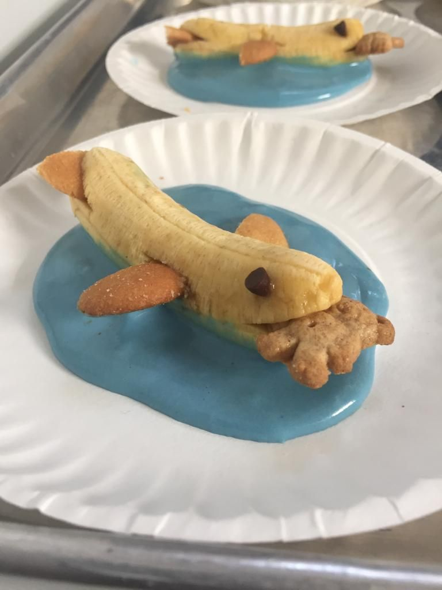
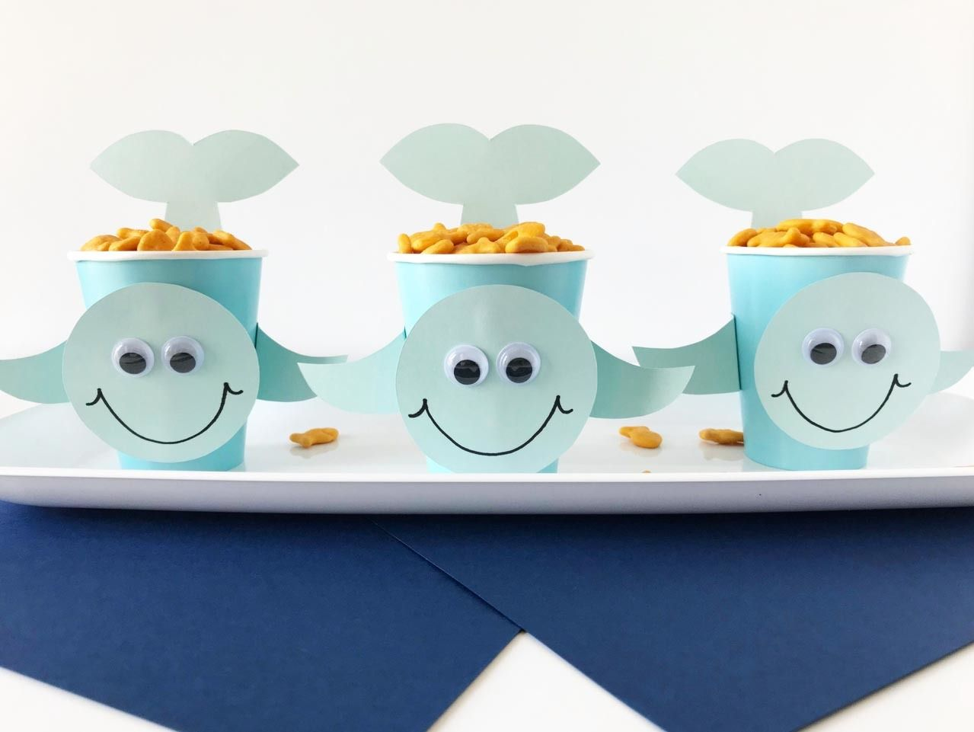
- You could make a camp or convert a tent into a whale
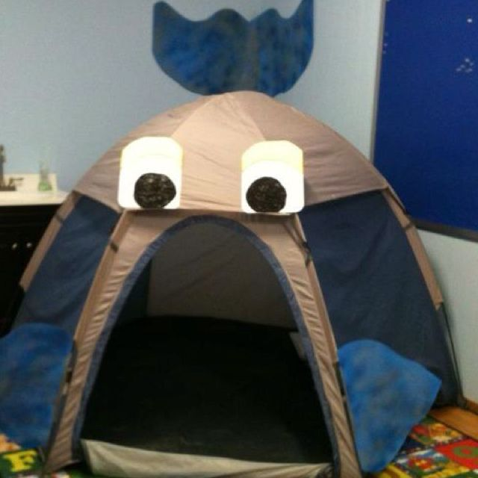

- Simple origami
Whale https://www.youtube.com/watch?v=hjole5KutUA
Dog https://www.youtube.com/watch?v=wWVppdfYOx8
Heart https://www.youtube.com/watch?v=Z-BIL6p1Te8

