Samuel craft ideas
The first craft is made from paper and you can download the pdf for it.
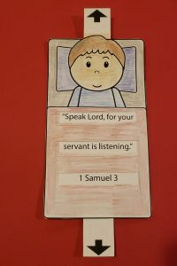
This craft uses a match box but you could use any other small box that you have. Don’t forget the bible verse that goes inside.
