Queen Esther Craft Ideas
You could make a crown of your own design and write on it ‘Brave Queen Esther’. Here are some crown to give you some other ideas.
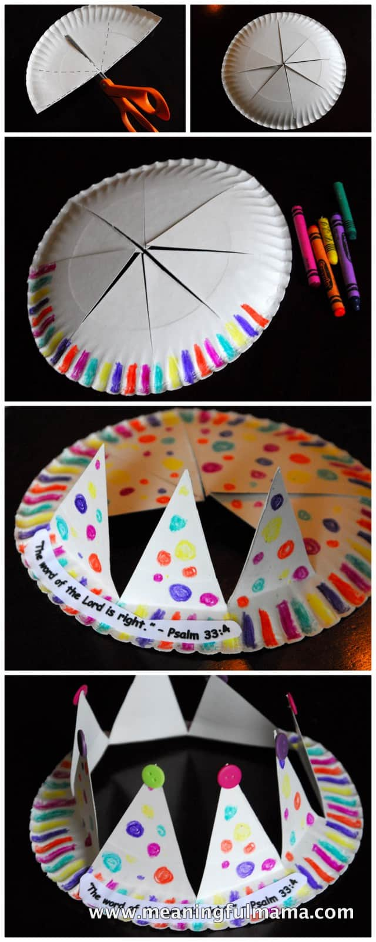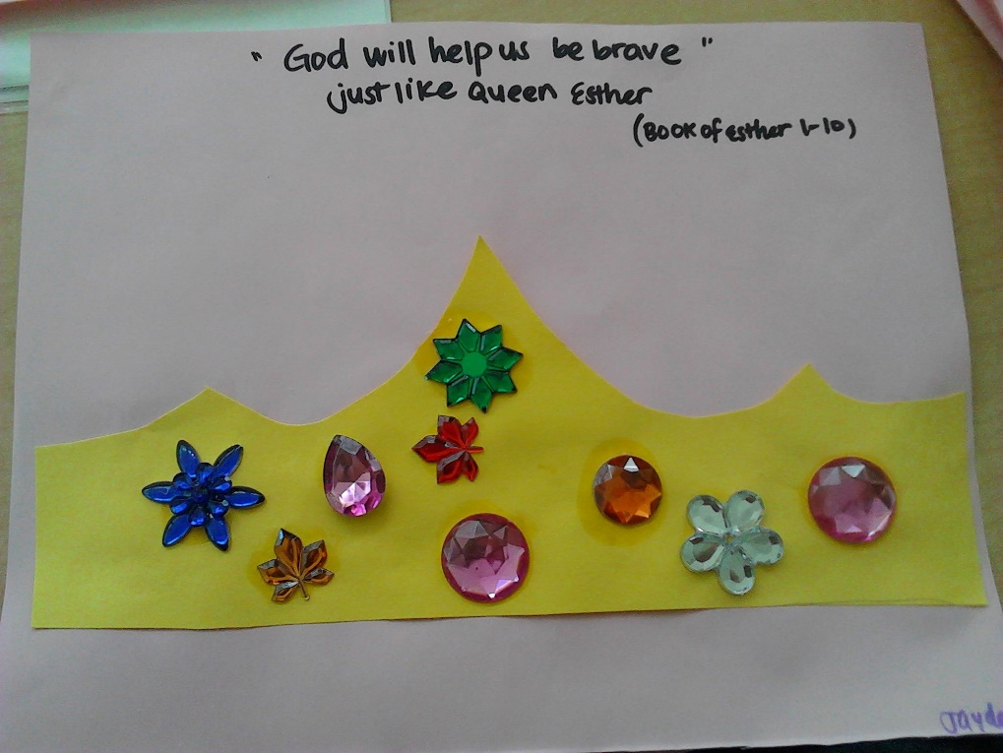
You could make a crown using food the first uses biscuits and icing and the second is the healthy option using yoghurt and fruit.
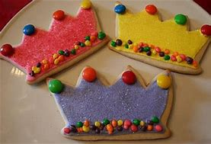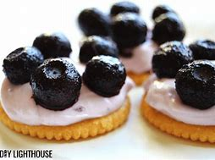
You could draw a beautiful queen Esther and attach her to a lollipop stick so she can stand up to remind you of how she stood up for what was right.
