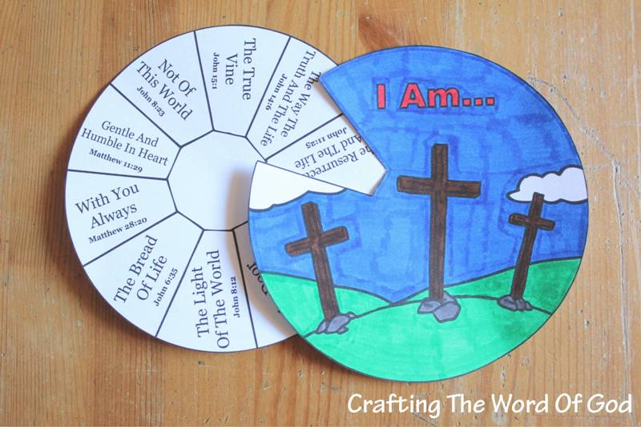

You could use 2 pieces of paper or thin card or 2 paper plates. You could also fix them together in the middle with a paper fastener to turn the top picture over the bottom words.

