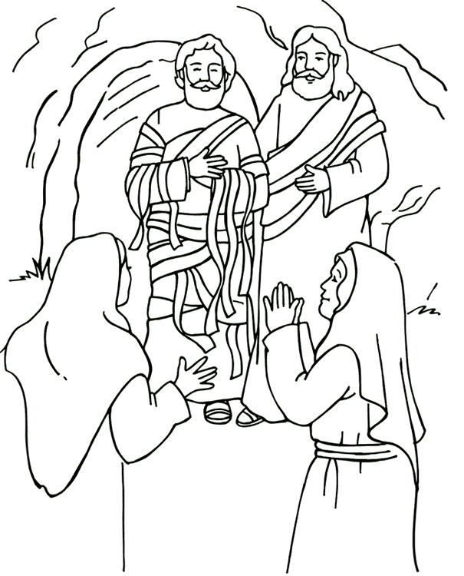

Jesus raises Lazarus.
Luke 10 John 11

