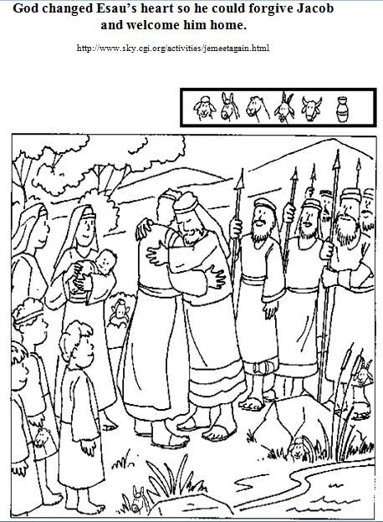
Here is a picture that you can colour. Also there are some hidden things to find

