Jacob and Esau Forgiveness Craft Ideas
You could make a picture with 2 people one dressed like Jacob and one dressed like Esau and write in the word Forgiveness. You could draw the picture and colour them or use materials to dress them. Remember Esau had a lot hair than Jacob.
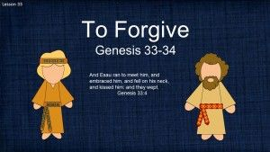
You could just have a picture of 2 hands shaking one for Jacob and one for Esau.
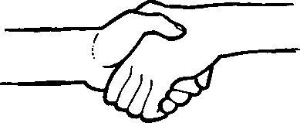
You could make or draw a symbol of forgiveness in the shape of a heart or hands like this or your come up with your own idea.

