There are many craft possibilities about creation. You can make something that describes the different days of creation or make a picture that includes everything or pick a plant or animal that you would like to make. There are many ideas on the internet. Here are just a few.
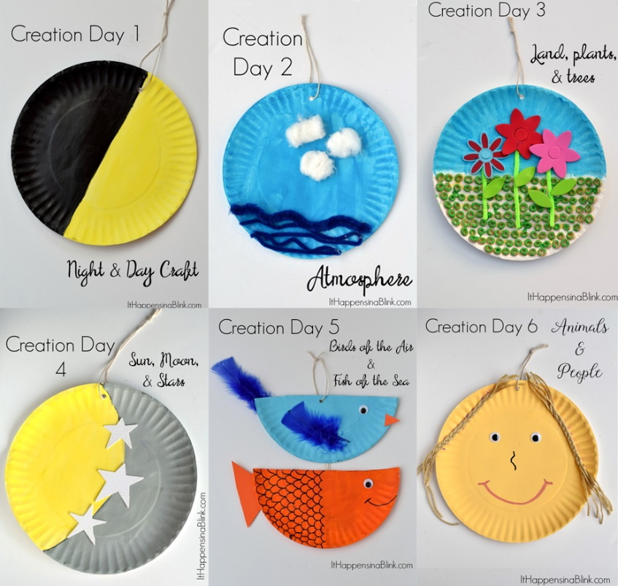

You can make a mobile with numbers or just pictures (see next picture)
