Lighting up the dark
Photography Competition

Entry form

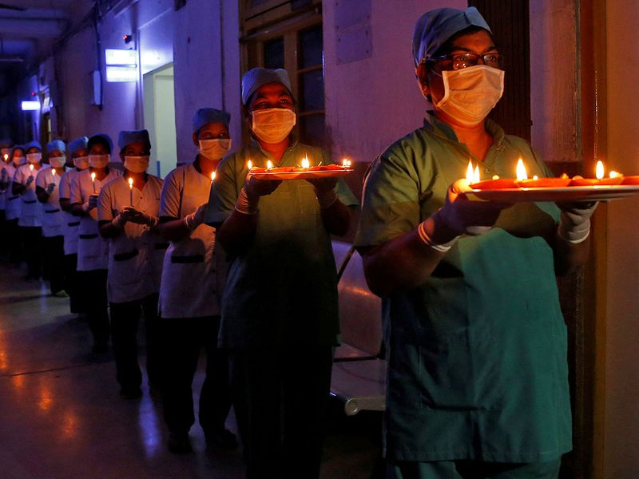

Take a photograph that shows something that has
brought light to you during these dark times.

NAME

ADDRESS

PHONE

EMAIL

AGE CATEGORY:
Child – up to 16
Young adult – 17-25
Adult
REASON FOR SELECTING YOUR PHOTO
NAME OF PHOTO
(if applicable)

Please submit your photo by Tuesday 1st June to Bowthorpe Church.
It should be A4 in size and placed in a cardboard mount and submitted along with this entry form.
Photographs will be exhibited at the Bowthorpe Arts Festival 26-27 June 2021 @ Bowthorpe Church.
Maximum number of entries – 3

