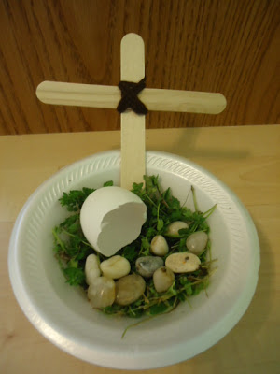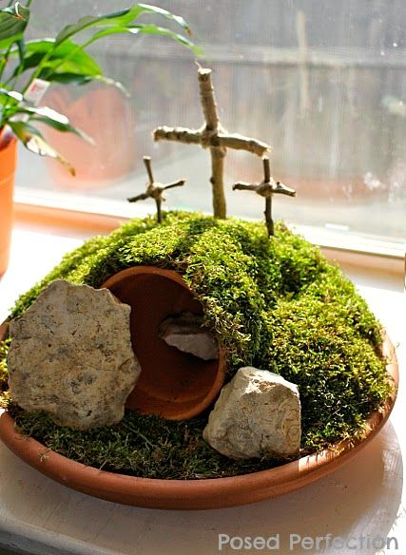

Easter gardens can be made in many different ways. Have a look in your garden and see what materials you have.
Or why not try an edible garden using biscuits, cake and sweets.
When you have made one take a photo I would love to see your creation
